UNIVERSITY OF RWANDA
COLLEGE OF SCIENCE AND TECHNOLOGY
SCHOOL OF ICT
COMPUTER ENGINEERING DEPARTMENT
GIKONDO CAMPUS
MODULE CODE/TITLE: WEB DESIGN
PROJECT TECHNICAL REPORT
WEB TECHNOLOGY TECHNICAL ASSESSMENT 2026
University Lost & Found Portal
Prepared by:
GIHOZO ANGE CHANELLA
Registration Number: 225059939
Course: Web Design
Submission Date: 19 July 2026

Table of Contents
Table of Contents 2
Table of Figures 3
List of Abbreviations 4
Chapter 1. Introduction 5
1.1. Historical Background of the Case Study 5
1.2. Problem Statement 5
1.3. Objectives of the Project 5
1.4. Expected Outcomes 6
1.5. Project Rationale (Importance to the Community) 6
Chapter 2. System Analysis and Design 7
2.1. System Analysis 7
2.1.1. Intended Users of the Project 7
2.1.2. Intended System Partners 7
2.2. System Design 7
1. High-Level Architecture 7
2. UI Design (Sketch of the UI Module) and Flowcharts 8
3. Database Design with ERD and Relationships 10
Chapter 3. Implementation 11
3.1. Introduction of the Section 11
3.2. Homepage, Login Page, Sign-Up Page, Dashboard, Report Lost Item, Report Found Item, and Reports Overview 11
Chapter 4. Conclusion and Recommendation 19
State of the Implemented System 19
Recommendations 19
Appendix 21

Table of Figures
High-level architecture of the University Lost & Found Portal 8
Flowchart of the lost and found reporting and claim process 10
Entity Relationship Diagram (ERD) of the University Lost & Found Portal database 10
University Lost & Found Portal — Homepage 11
Login Page — Welcome Back 13
Sign-Up Page — Create Your Account 14
User Dashboard 15
Report Lost Item Form 16
Report Found Item Form 17
Reports Overview Page 18

List of Abbreviations
UR — University of Rwanda
UI — User Interface
ERD — Entity Relationship Diagram
HTML — HyperText Markup Language
CSS — Cascading Style Sheets
JS — JavaScript
CRUD — Create, Read, Update, Delete

Chapter 1. Introduction

1.1. Historical Background of the Case Study
The University of Rwanda, Gikondo Campus, is a large institution with several faculties, lecture halls, hostels, libraries, and shared social spaces. As with any busy campus environment, students and staff regularly misplace personal belongings such as keys, student identification cards, national IDs, mobile phones, chargers, clothing items, books, and other small valuables. Historically, the campus has had no dedicated, centralized system to handle these situations. When a student loses an item, they typically rely on informal channels: asking close friends if they have seen the item, checking physical notice boards scattered around campus, or posting a message in one of several WhatsApp groups shared by students.
These informal methods, while well-intentioned, are inconsistent and unreliable. A notice posted on a board in one building is invisible to students who never pass by that location. A message sent in a WhatsApp group is quickly buried under dozens of unrelated messages within minutes, especially in groups that are already used for class updates, event announcements, and casual conversation. As a result, many lost items are never reunited with their owners simply because the person who found the item and the person who lost it never learned of each other's existence. This gap in communication was the starting point for the University Lost & Found Portal.

1.2. Problem Statement
Because the University of Rwanda campus is large and spread across multiple buildings and blocks, there is no single, reliable, and easily accessible place where a student, staff member, or visitor can report a lost item or a found item and expect the right person to see that report in good time. Existing channels — word of mouth, physical notice boards, and overloaded WhatsApp groups — are fragmented, easily missed, and not searchable. There is also no formal way to verify that a person claiming an item is truly its owner, which discourages people from handing found items to strangers. This creates a situation where valuable and sentimental belongings are lost permanently, even when someone on campus has already found them.

1.3. Objectives of the Project
The University Lost & Found Portal was designed with the following objectives:
- To provide a single, centralized web platform where members of the university community can report lost items and found items.
- To allow users to create personal accounts so that their reports and claims can be tracked over time.
- To organize reported items by category (e.g. electronics, documents, clothing) to make browsing and matching faster.
- To allow a user who believes an item found by someone else belongs to them to submit a claim on that item.
- To give the university security office and administrators visibility over all lost and found reports so that verification and hand-over of items can be coordinated.
- To replace informal, easily-missed communication channels (WhatsApp groups, notice boards) with a structured, searchable digital record.

1.4. Expected Outcomes
By the end of this project, the University Lost & Found Portal is expected to give students and staff a straightforward way to sign up, log in, and submit a lost or found item report through a simple form. Reports are expected to be stored and organized by category so that browsing existing reports is quick and intuitive. Users who recognize an item in the found list are expected to be able to submit a claim, which can then be reviewed. The system's dashboard should give each user a personal overview of their own lost and found activity, and a reports page should give a consolidated view of all activity on the platform, replacing the need to scroll through WhatsApp groups or check multiple notice boards around campus.

1.5. Project Rationale (Importance to the Community)
This project matters to the University of Rwanda community because it directly addresses a small but recurring source of daily frustration and financial loss for students and staff. A lost student ID, phone, or set of keys can disrupt someone's ability to attend class, access their room, or communicate with family, sometimes for days while replacement documents are processed. By making it easy to report and search for lost and found items in one place, the portal reduces the time items spend unclaimed, reduces reliance on chance encounters or overloaded group chats, and gives the security office a clearer picture of what is circulating on campus. In the long run, a tool like this also builds trust and cooperation within the campus community, since it shows that there is a dependable, official channel for honesty when someone finds something that is not theirs.

Chapter 2. System Analysis and Design

2.1. System Analysis

2.1.1. Intended Users of the Project
The University Lost & Found Portal is designed around three main groups of users, each interacting with the system in a slightly different way:
- Students — the primary users of the platform. They report items they have lost, report items they have found belonging to someone else, browse existing reports, and submit claims when they recognize an item as their own.
- Staff — academic and administrative staff members who, like students, may lose or find personal items on campus and use the same reporting and claiming features.
- Security Office — the campus security office acts as the verifying authority. Because they are typically the physical custodians of valuable found items handed in by good citizens, they use the platform's reports view to cross-check claims before releasing an item to the person claiming it.

2.1.2. Intended System Partners
The main institutional partner for this system is the University of Rwanda's Campus Security Office, since it is the office most directly responsible for the physical safety and management of lost property on campus today. The platform is designed so that, going forward, the security office could adopt it as their official channel for logging found items that are physically handed in to them, replacing the current informal system of paper logs and word-of-mouth. Academic departments and student affairs offices are secondary partners who could help publicize the platform to new students during orientation.

2.2. System Design

1. High-Level Architecture
The system follows a simple three-layer, client-side web architecture appropriate for a project built with HTML, CSS, and JavaScript. The Presentation Layer consists of the HTML pages and CSS styling that make up every screen the user sees — the homepage, authentication pages, dashboard, reporting forms, and the reports view. The Application / Logic Layer is made up of JavaScript modules that handle form validation, session and login checks, the creation and reading of reports, claims and items, and dynamic rendering of content on the page (for example, updating the dashboard counters or showing 'No reports yet' when a list is empty). The Data Layer is responsible for persisting the core data of the system: users, reports, items, claims, and categories. Figure 1 below illustrates how these layers communicate with one another and with the end user.
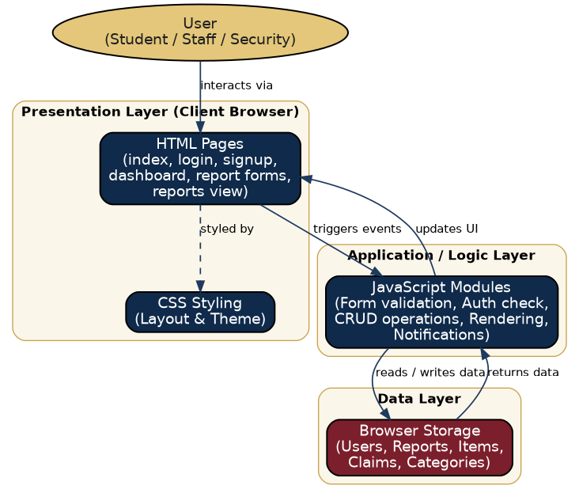
Figure 1: High-level architecture of the University Lost & Found Portal

2. UI Design (Sketch of the UI Module) and Flowcharts
The user interface was designed to feel welcoming and trustworthy, using a navy-and-gold colour palette that reflects a formal, university-appropriate tone while remaining friendly. Every page follows a consistent header pattern with the portal's logo and primary navigation, and every form follows the same layout convention (a two-column grid of clearly labelled fields, required fields marked with an asterisk) so that users who have filled in one form immediately understand how to fill in the next. The flowchart in Figure 2 illustrates the core journey a user follows: logging in, choosing whether they are reporting a lost or a found item, submitting the relevant form, and then how that report can eventually lead to a claim being verified and an item being returned to its owner.
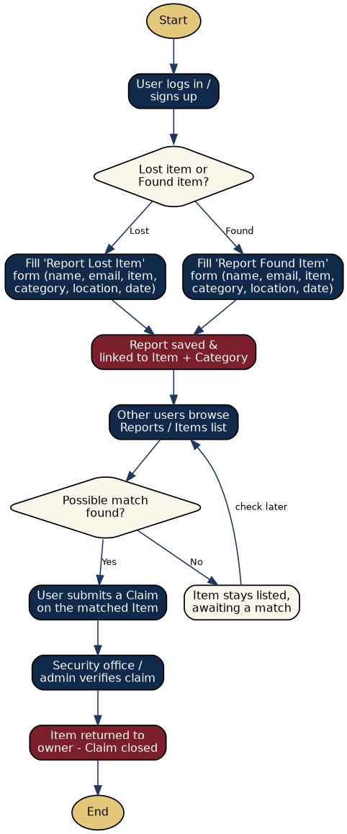
Figure 2: Flowchart of the lost and found reporting and claim process

3. Database Design with ERD and Relationships
The system's data model is built around five core entities: User, Report, Item, Claim, and Category. A User can make many Reports and can submit many Claims, reflecting the fact that one person may report several lost or found items over time and may also claim more than one item. Each Item can be the target of many Claims (in case more than one person believes an item belongs to them, pending verification) and each Item can also be described by many Reports. Every Report belongs to exactly one Category, which keeps items organized (for example, Electronics, Documents, Clothing, Accessories) and makes browsing and searching far more efficient than a single unsorted list. Figure 3 shows the complete entity relationship diagram.
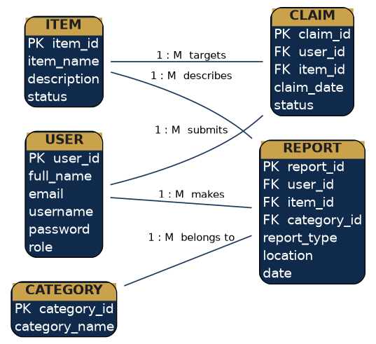
Figure 3: Entity Relationship Diagram (ERD) of the University Lost & Found Portal database

Chapter 3. Implementation

3.1. Introduction of the Section
This chapter presents the implemented screens of the University Lost & Found Portal, built using HTML, CSS, and JavaScript. Each screenshot below is accompanied by a discussion of its purpose, its main interface elements, and the role it plays within the overall lost-and-found workflow described in Chapter 2. The screens covered are: the homepage, the login page, the sign-up page, the user dashboard, the report lost item form, the report found item form, and the reports overview page.

3.2. Homepage, Login Page, Sign-Up Page, Dashboard, Report Lost Item, Report Found Item, and Reports Overview
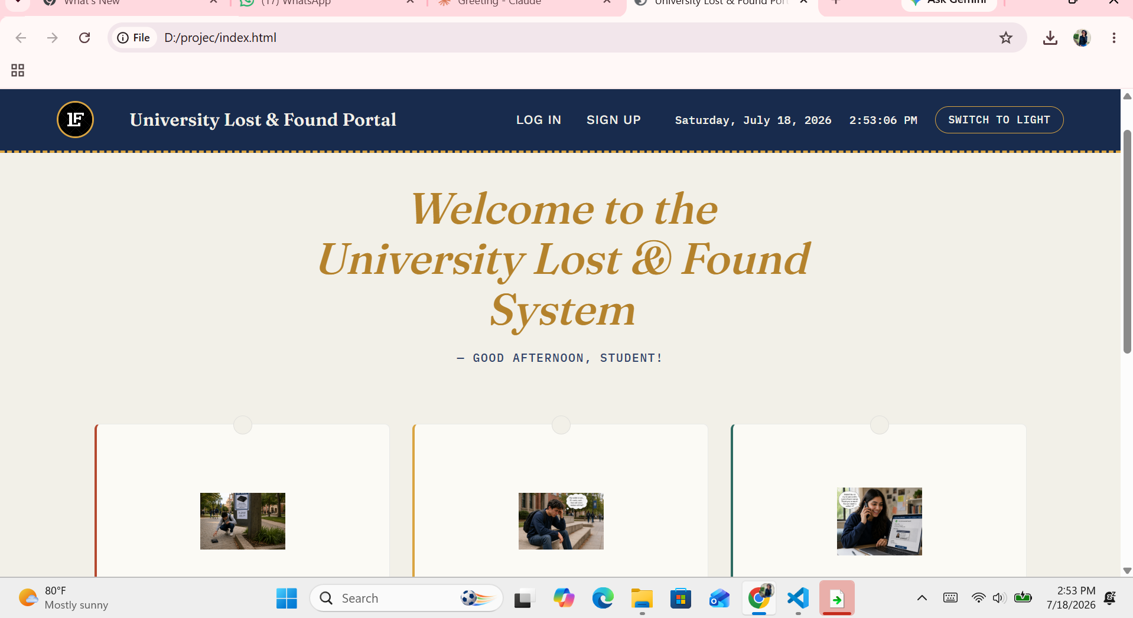
Figure 4: University Lost & Found Portal — Homepage
The homepage is the first point of contact for anyone visiting the University Lost & Found Portal, and it was designed to immediately communicate what the platform is for and who it serves. At the top, a fixed navigation bar carries the portal's logo and name, alongside quick-access LOG IN and SIGN UP buttons, a live clock showing the current date and time, and a light/dark theme toggle so users can choose the display mode that is most comfortable for them. Directly below the navigation bar, a bold welcome banner greets the visitor with a personalized message ('Good afternoon, student!'), which reinforces that the system recognizes context such as time of day. This kind of personalization, however small, makes the platform feel more like a helpful campus service and less like a generic form.
Beneath the welcome banner, three illustrated cards summarize the key situations a user might find themselves in — someone who has lost an item outdoors, someone sitting and thinking about where they might have dropped something, and someone reporting a find from their laptop. These illustrations were included deliberately to make the landing page feel human and relatable rather than purely functional, helping first-time visitors quickly understand the purpose of the site without needing to read a long paragraph of instructions. From a technical standpoint, the homepage is built using semantic HTML for structure, CSS for the navy-and-cream colour theme, card layout, and responsive spacing, and a small amount of JavaScript to power the live clock and the light/dark theme switch. The homepage does not require the user to be logged in, which is intentional: any visitor, including someone who has just found an item and does not yet have an account, should be able to see what the platform offers before deciding to sign up. From here, the natural next steps are either the SIGN UP button for a first-time user or the LOG IN button for a returning one, both of which are always visible in the navigation bar no matter how far the visitor scrolls down the page.

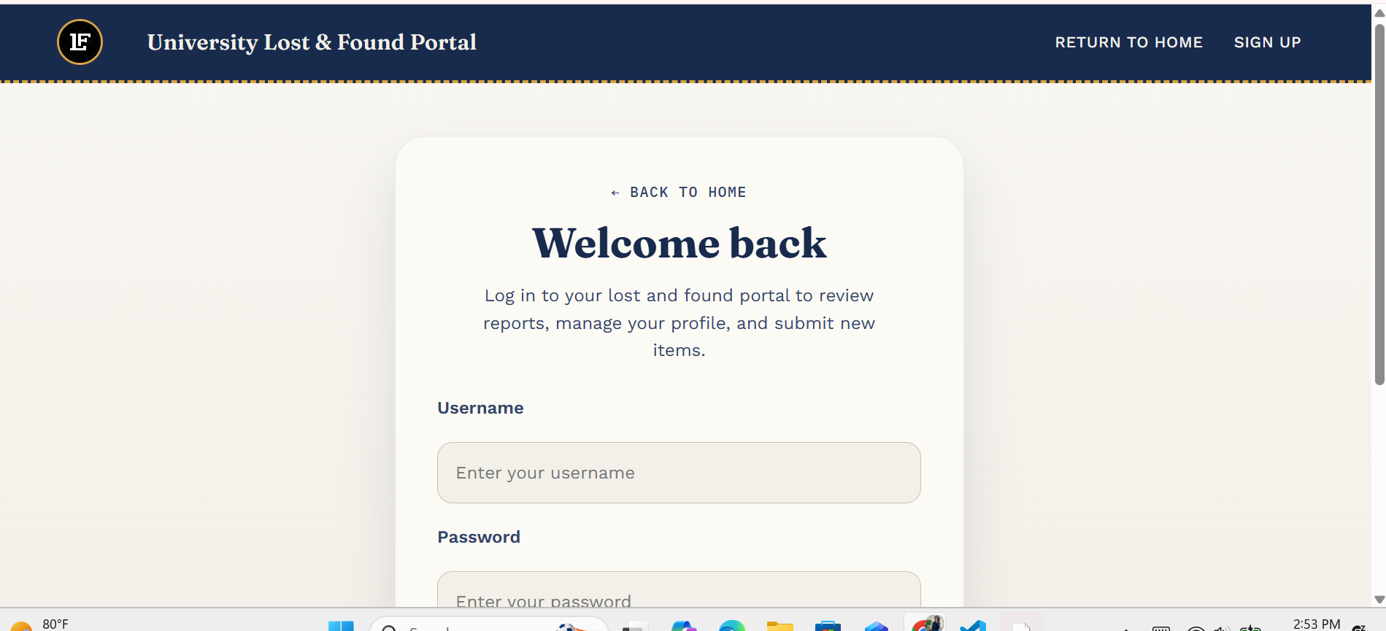
Figure 5: Login Page — Welcome Back
The login page allows a returning user to authenticate and gain access to their personal dashboard. It follows a focused, single-column card layout centred on the page, deliberately free of distracting navigation elements apart from a 'Back to Home' link and a 'Sign Up' option for users who do not yet have an account and land here by mistake. The heading 'Welcome back' together with a short supporting sentence reminds the user what logging in unlocks: reviewing reports, managing their profile, and submitting new items. This context is useful because it re-motivates the user to complete the login rather than abandoning the page.
The form itself asks only for a Username and a Password, keeping the login process as short as possible, which reduces friction and encourages more students to actually use the system rather than falling back on WhatsApp groups. Placeholder text inside each input field ('Enter your username', 'Enter your password') guides the user on what is expected without needing separate instructional text above the fields. On the implementation side, JavaScript is responsible for validating that both fields are filled before submission, checking the entered credentials against the stored user records, and redirecting the user to their personal dashboard on success. If the credentials do not match any stored account, the same JavaScript logic is responsible for surfacing a clear error message so the user knows to check their username and password rather than being left wondering why nothing happened. This page is the gate that separates the public-facing homepage from all the personalized, account-specific features described in the rest of this chapter, so its simplicity and clarity were treated as a priority during design.

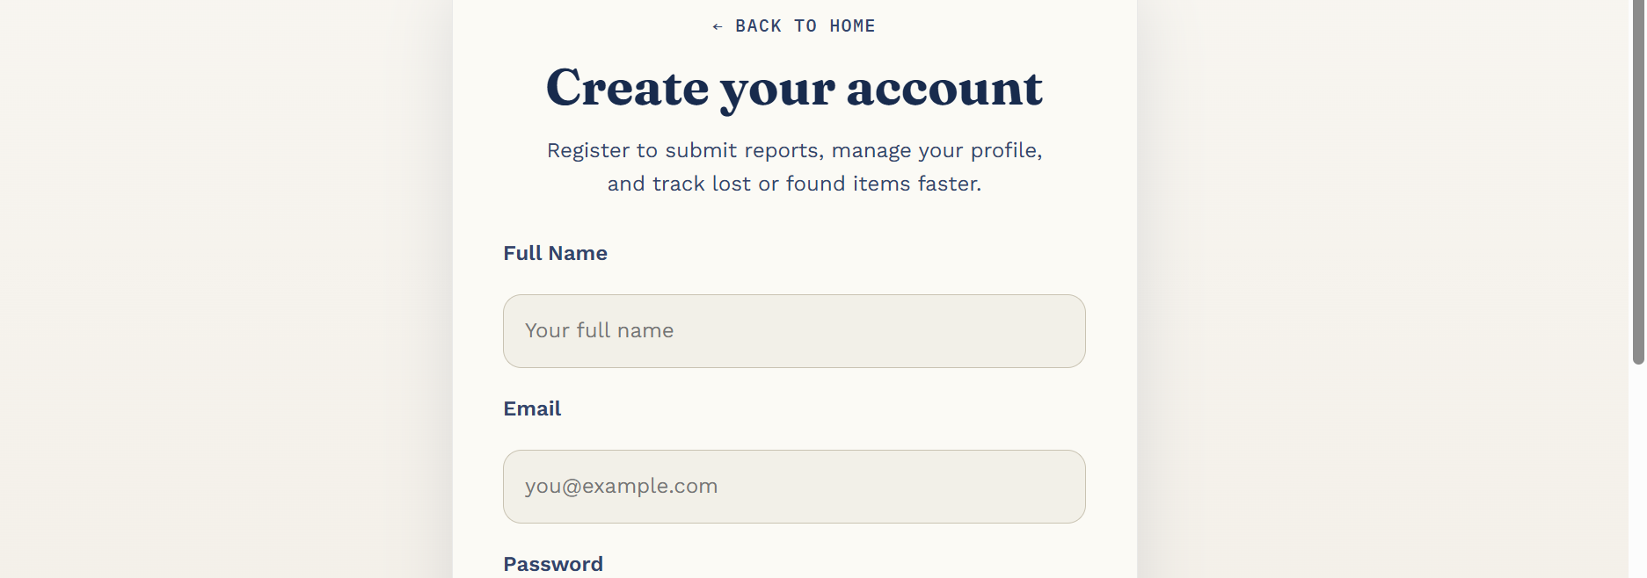
Figure 6: Sign-Up Page — Create Your Account
The sign-up page is where a new visitor — typically a student or staff member using the platform for the first time — creates the account they will use for every future interaction with the system. Like the login page, it uses a clean, centred card layout with a 'Back to Home' shortcut at the top, and it opens with a short explanatory line describing what registering unlocks: submitting reports, managing a profile, and tracking lost or found items faster. This framing helps first-time users understand the value of creating an account instead of treating registration as an obstacle.
The form collects the essential information needed to identify a user and allow them to log back in later: Full Name, Email, and Password (with the password field continuing below the visible area of the screenshot). Full Name is used throughout the rest of the system to personalize the dashboard greeting and to identify who made a particular report or claim, which is important for accountability — especially for the security office, who need to know exactly who reported or claimed a given item. Email is stored as a contact channel and a potential secondary identifier. On submission, JavaScript validates that all required fields are completed and that the email address is in a valid format, then creates a new user record before redirecting the new account holder to the login page (or directly into their dashboard, depending on the flow configured). Keeping the registration form short — only three fields — was a deliberate design decision to reduce drop-off, since a lengthy sign-up form is one of the most common reasons students abandon a new platform before ever using its core features.

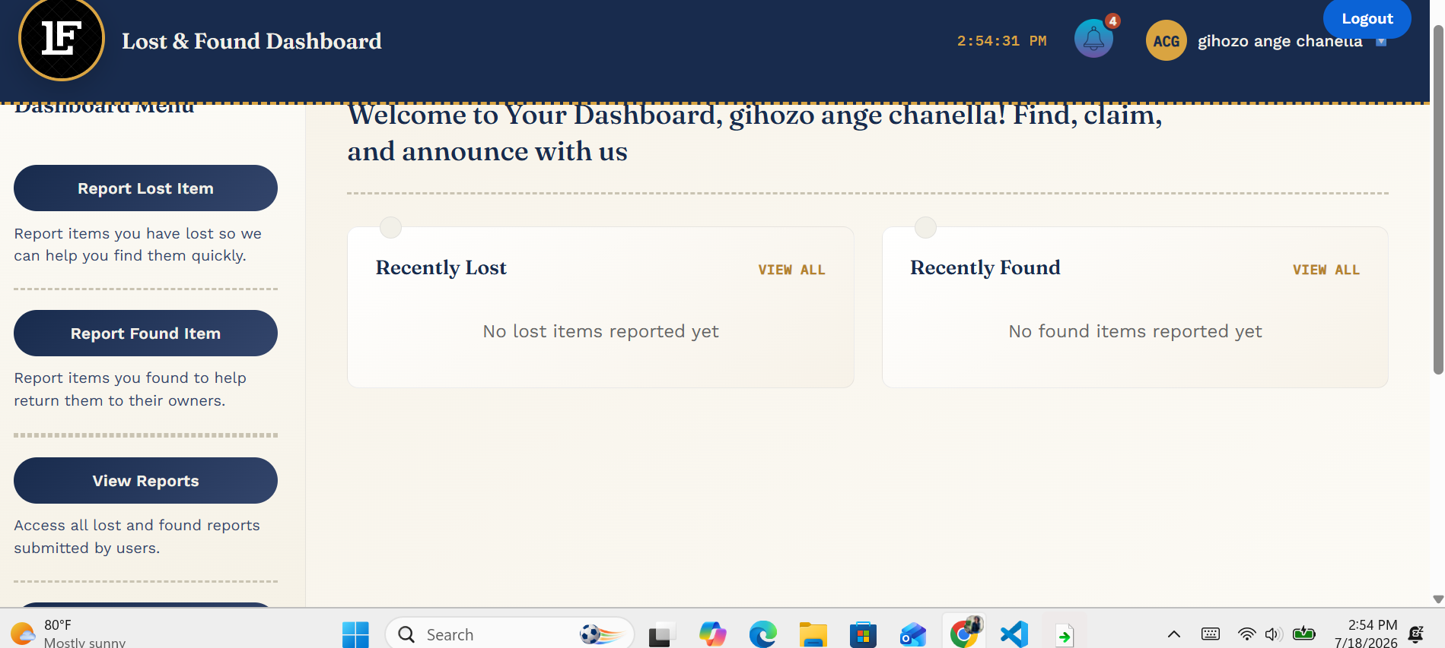
Figure 7: User Dashboard
Once logged in, every user lands on their personal Dashboard, which acts as the control centre for the entire platform. The top navigation bar changes from the public homepage version to an authenticated version: it now shows a notification bell (with a live count of unread notifications), the user's initials in an avatar badge, their full name ('gihozo ange chanella'), and a Logout button, replacing the generic Log In / Sign Up buttons seen by unauthenticated visitors. This immediately confirms to the user that they are logged in and shows them who they are logged in as, which is a small but important trust signal.
On the left, a persistent Dashboard Menu gives access to the platform's three central actions: Report Lost Item, Report Found Item, and View Reports, each with a short description underneath explaining what the action does. Placing these three actions permanently in a side menu, rather than burying them in a dropdown, means a returning user can go from login to submitting a report in a single click. The main panel of the dashboard greets the user by name and then shows two summary cards, 'Recently Lost' and 'Recently Found', each with a 'View All' shortcut. In this fresh account, both cards correctly display 'No lost items reported yet' and 'No found items reported yet', which confirms that the dashboard's JavaScript logic checks the stored reports for the logged-in user and gracefully falls back to an empty state message rather than showing a blank or broken section when there is no data yet. Once reports exist, these same cards are designed to populate with the most recent entries, giving the user an at-a-glance summary of their own activity without needing to navigate to the full Reports page every time.

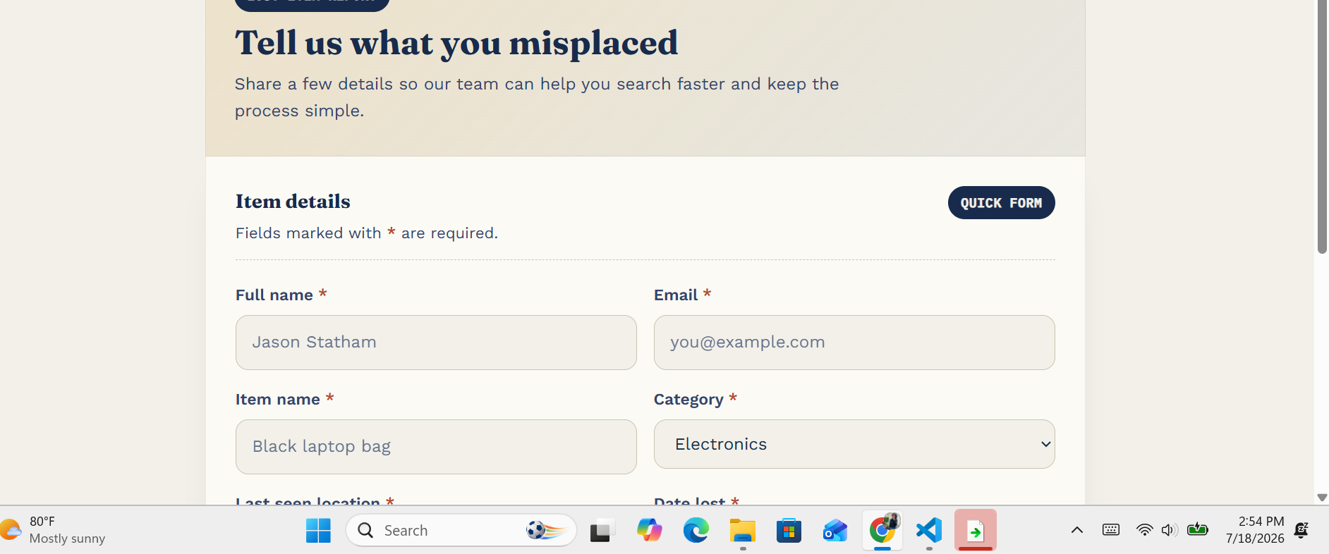
Figure 8: Report Lost Item Form
The Report Lost Item page is where a user formally logs an item they have misplaced somewhere on campus. The page opens with a warm, reassuring heading, 'Tell us what you misplaced,' and a short line explaining that sharing a few details helps the team search faster — framing the form as help rather than paperwork. A 'Quick Form' toggle in the top-right corner suggests that the interface also supports a shortened version of the form for users in a hurry, in addition to the full version shown here.
The form is organized into a clean two-column grid, with required fields clearly marked using a red asterisk next to the label, and helpful placeholder text inside each input (for example 'Jason Statham' for Full Name and 'Black laptop bag' for Item name) to show the expected format rather than leaving fields ambiguous. The captured fields include Full Name and Email (to identify who is making the report and how to reach them), Item Name and Category (a dropdown, seen here set to 'Electronics', which maps directly onto the Category entity described in the Chapter 2 ERD), and continuing below the visible area, Last Seen Location and Date Lost. On submission, JavaScript validates that every required field has been filled in, creates a new Item record if one does not already exist, creates a Report record linked to that Item, the submitting User, and the chosen Category, and then updates the dashboard's 'Recently Lost' card and the Reports page so the new entry is immediately visible platform-wide. This is the core data-entry point that feeds the 'lost' side of the matching process illustrated in the Chapter 2 flowchart.

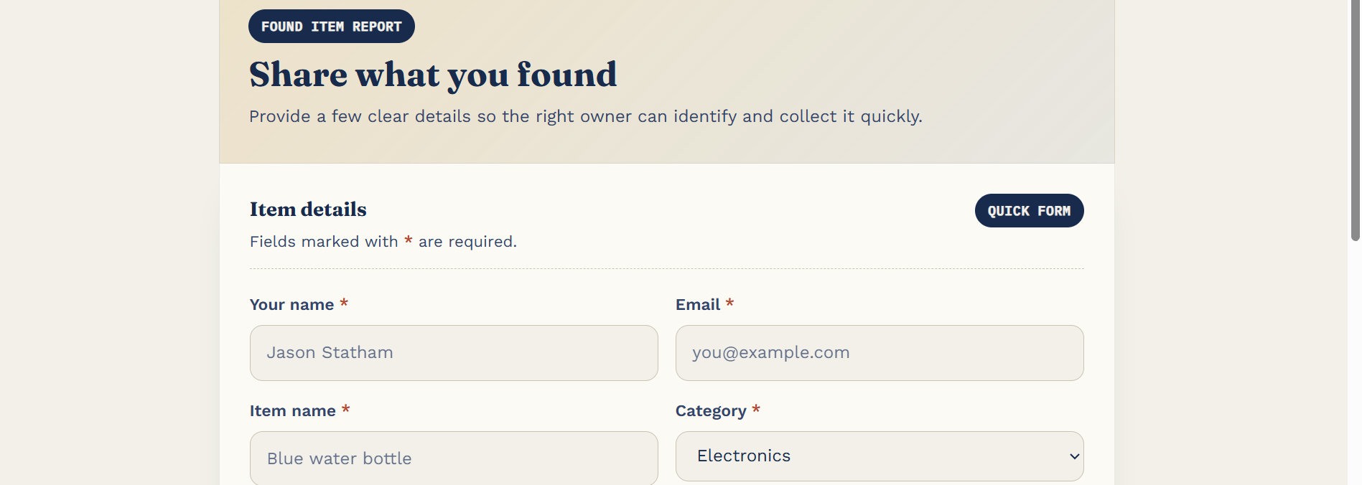
Figure 9: Report Found Item Form
The Report Found Item page mirrors the Report Lost Item page closely, both visually and functionally, which was a deliberate consistency decision: a user who has already learned how to fill in one form should be able to fill in the other without any new learning curve. The heading changes to 'Share what you found,' with supporting text asking the user to provide clear details so the rightful owner can identify and collect the item quickly — subtly encouraging honesty and thoroughness from the person who found the item, since they are typically not the one who will benefit directly from the report.
The same field structure is reused — Your Name and Email, Item Name and Category — with the example placeholder changed to 'Blue water bottle' to reflect a found-item context. Reusing the exact same visual language (the same 'Quick Form' toggle, the same asterisk convention, the same two-column layout) across both the lost and found forms was a conscious front-end decision, since the underlying data model treats both as instances of the same Report entity, distinguished by a report type indicating whether the item was lost or found. On submission, the JavaScript logic behaves similarly to the lost-item form: it validates the inputs, creates or matches an Item record, creates a Report linked to the reporting User and the selected Category, and makes the found item visible to other users browsing the Reports page — allowing someone who has lost a matching item to recognize it and proceed to submit a Claim, completing the loop illustrated in the Chapter 2 flowchart.

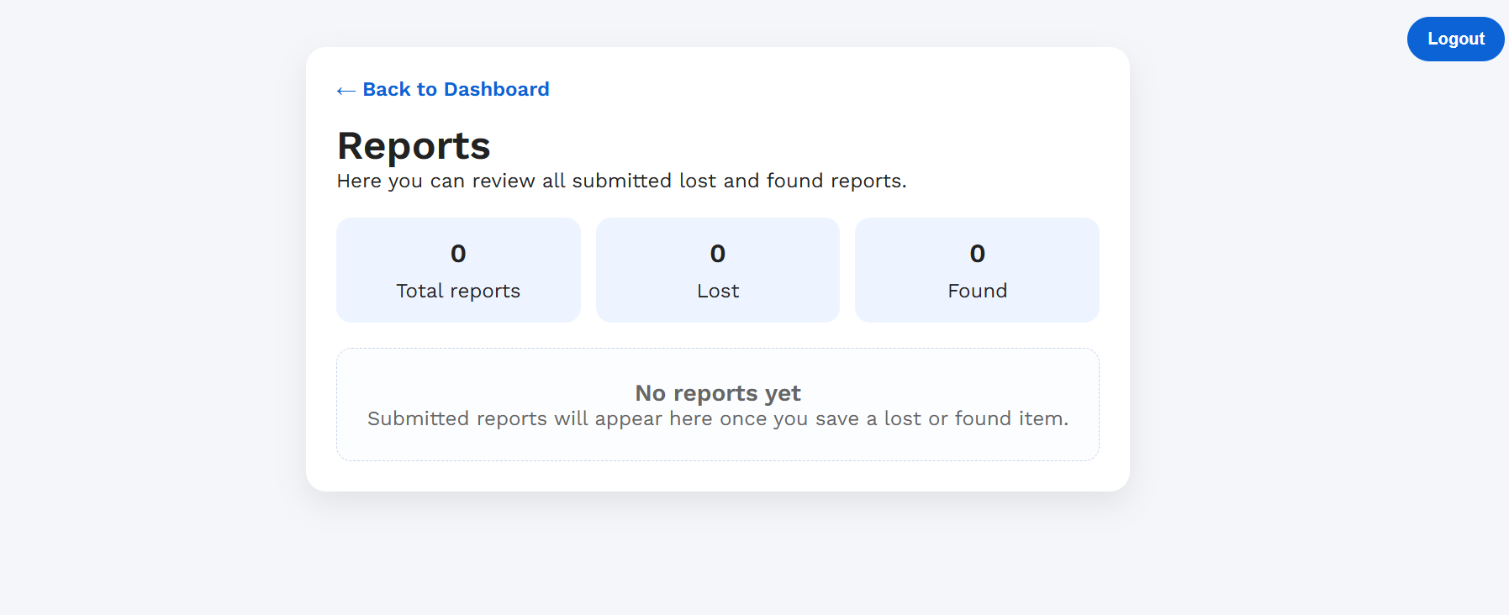
Figure 10: Reports Overview Page
The Reports page gives every user — and, most importantly, the security office — a consolidated view of everything that has been reported on the platform, replacing the need to scroll through scattered WhatsApp messages or check multiple physical notice boards. A 'Back to Dashboard' link keeps navigation consistent with the rest of the authenticated experience, and the page opens with a short explanatory line: 'Here you can review all submitted lost and found reports.'
Three summary statistic cards sit at the top of the page — Total reports, Lost, and Found — each showing a live count drawn from the underlying data. In this screenshot, all three read zero because the account is new and no reports have been submitted yet, which, just as on the Dashboard, confirms that the counters are calculated dynamically from stored data rather than hard-coded. Below the statistics, an empty-state message, 'No reports yet — Submitted reports will appear here once you save a lost or found item,' is shown instead of a blank list, guiding the user on what to do next rather than leaving them uncertain about whether the page is broken. Once reports exist in the system, this same page is designed to list each one with its item name, category, reporter, and status, giving the security office a searchable, always up-to-date register they can use to verify claims before releasing any found item — directly fulfilling one of the core objectives set out in Chapter 1: replacing fragmented, easily-missed communication with a single structured and reliable record.

Chapter 4. Conclusion and Recommendation

State of the Implemented System
At the point of submission, the University Lost & Found Portal has achieved approximately 80% of its planned objectives. The core user-facing workflow is fully functional: visitors can view the homepage, create an account through the sign-up page, log in, and access a personalized dashboard. From the dashboard, users can submit both Report Lost Item and Report Found Item forms, with data organized by category as designed in the Chapter 2 ERD, and can view a consolidated Reports overview showing live statistics for total, lost, and found reports. The visual design, navigation flow, and empty-state handling (shown throughout Chapter 3) are complete and consistent across every page.
What remains only partially implemented is the full claim-verification loop described in the Chapter 2 flowchart — specifically, a dedicated interface for the security office to review a submitted claim against a found item and mark it as resolved, and a richer search and filter experience on the Reports page so that browsing a large number of reports remains fast as the platform's usage grows. These remaining pieces build directly on top of the Report and Claim data structures that are already in place, so completing them is a matter of extending existing logic rather than redesigning the system.

Recommendations
Based on the outcome of this project, the following recommendations are offered to each stakeholder group involved:
To the Lecturer, on technicalities:
Guidance on structuring client-side data persistence for multi-user web applications (built without a backend framework) earlier in the module would help students design cleaner data models from the start, rather than restructuring them midway through development.
To the School, on time constraints:
A project of this scope — covering authentication, multiple data entities, and a full reporting workflow — benefits from more time allocated between the topic briefing and the submission deadline, particularly for students balancing this assessment with other modules.
To the Partners (Campus Security Office), on the app developed:
The security office is encouraged to pilot the Reports page as a supplementary log alongside their current process, since it already gives them a live, searchable count of lost and found activity that no existing tool on campus currently provides.
To the Users, on training:
A short orientation session — even a single-page printed guide distributed during student orientation week — would help students understand that this platform exists as an alternative to WhatsApp groups and notice boards, which is currently the biggest barrier to adoption for any new campus tool.
To the Beneficiaries (students on campus), on the new technological tool:
Students are encouraged to make reporting a habit — both when they lose something and, just as importantly, when they find something belonging to someone else — since the system's usefulness grows directly with how consistently the community chooses to use it instead of informal channels.

Appendix
GitHub Repository Link: https://github.com/ange-ce/lost-and-found
Access: Public repository — no account or password required to view the source code.

